Biology Study Guide, Semester 1 Name_________________________________________hour_______
*You may use a double sided, regular sized, unlined paper that is provided to handwrite content from Semester 1 for use during your exam. You may not use this handout.

Unit 1: Themes, Scientific Method, Chemistry of Life (Chapter 1 and 2)
___understand the definition of biology
___summarize the 7 themes of life – describe each term
___describe the scientific process
___evaluate experimental factors (variables, constant, control trial)
___describe the parts of an atom (charges)
___describe the chemical properties (polarity and structure) of water
___distinguish between acids and bases and explain their characteristics and how they are measured
___summarize the characteristics of the 4 macromolecules (function, building block, examples)
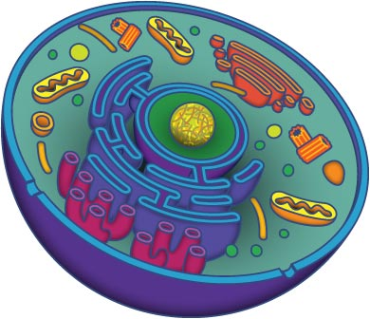
___define all vocabulary from Chapter 2, Sections 1,2&3 (p.43)

Unit 2: Photosynthesis and Respiration (Chapter 5)
___ compare and contrast autotrophs and heterotrophs
___ describe how the cell uses ATP
___ summarize the reactions for photosynthesis and respiration and where they occur
___ define all vocabulary from Chapter 5 (p.111)

Unit 3: Mitosis and Meiosis (Chapter 6 and 7)
___differentiate the hierarchical structure of genetic material (DNA, chromatid, chromosome, centromere)
___explain the major events of the cell cycle
___relate the role mitosis in relation to cancer
___explain how changes in chromosome number or structure can affect development
___evaluate the result of mitosis, in terms of type of cell and genetic material
___define all vocabulary from Chapter 6 (p.133)
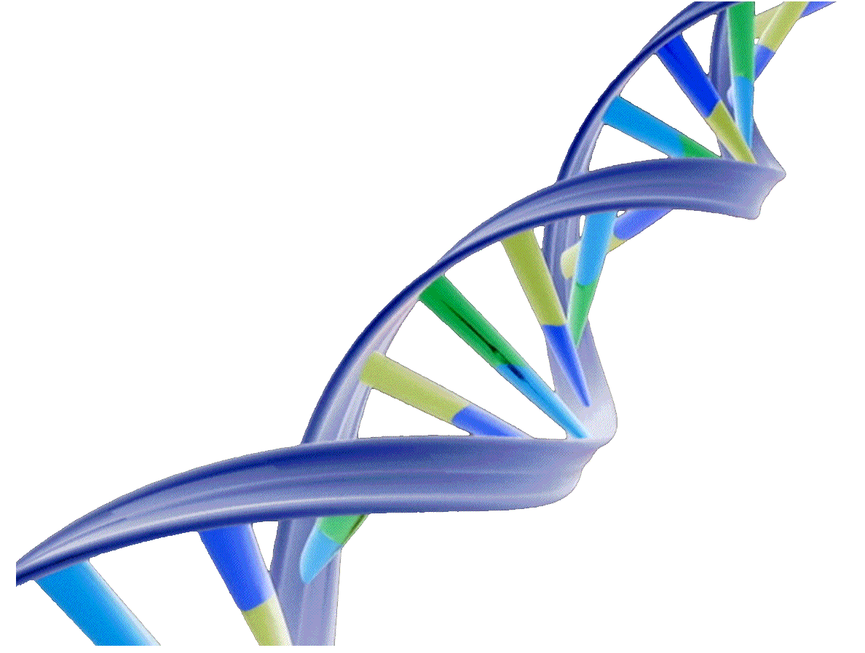
Unit 4: DNA and Replication (Chapter 9)
___ describe the structure of DNA
___ describe the role of DNA in a living organism
___ describe the process of Replication
___ describe the functions of both enzymes in Replication

